Press Release: June 2022

Film Premiere of makes a posthumous star of Manchester-based, Czech-HGV Driver turned social media star and Roma-rights campaigner…
PONGO CALLING
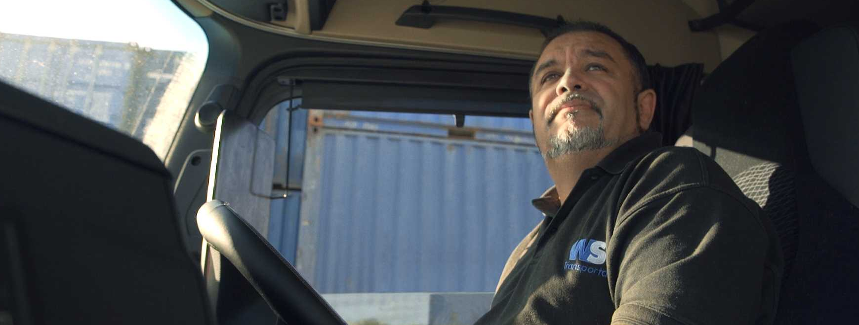

PONGO – World Premiere at Sheffield Doc/Fest – Fri 24 June 2022
Director: Tomáš Kratochvíl

All Screenings:
Fri 24 June - 8:30pm - Showroom Cinema 1
Sat 25 June 10:30am - Showroom Cinema 3
Tue 28 June 4:00pm - Odeon Cinema 1
www.pongocalling.com / Link to trailer: https://vimeo.com/716584148

Having arrived in the UK as a member of the persecuted Roma minority of Czechia, working arduous shifts as an HGV driver away from his Manchester-home and family, mild-mannered Štefan Pongo was incensed by the racist slur made by Czech President, Miloš Zeman in 2018 that he, like all Romani people, was lazy. What happened next is told in the documentary film PONGO CALLING, following the late rights campaigner out of the cab of his lorry and into an unknown world of social media notoriety, street protests, the foundation of his own aid charity and seemingly endless arguments with his wife.

The moving film, directed by Czech filmmaker, Tomáš Kratochvíl, receives its WORLD PREMIERE at Sheffield Doc/Fest on Fri 24 June 2022, and tells the story of how the mild-mannered Pongo was drawn to initiate an international campaign to start redressing the balance, encouraging hard-working Roma-populations around the world to finally have their voices heard with a simple exchange of pictures, and draw attention to the real, dangerous and enduring threats to the minority community in Czechia, Slovakia and Europe-wide.

“Until that time, I had only identified as a child” is just one of the poignant lines articulated by Pongo as he reflects on the moment, in the school room, when his life changed, finding the shadow of prejudice finally catching up with him. Innocence lost. Unwilling to allow his own children to endure the same insults and injustices cast upon Roma communities, Pongo moved to the United Kingdom in 2006, settling down in Crumpsall, three miles north of Manchester city centre. Having worked tirelessly on the roads and seeing his two children into and graduate from university, the unjustified slur from the Zeman lit a fire in Pongo’s belly.

Guiding viewers from Prestwich to Brussels and on into the desperate, inhumane slums of Slovakia, where the pictures become difficult to watch, Pongo Calling’s story begins with one, simple Facebook video that then turns into hundreds as the driver-turned-campaigner becomes a source of inspiration, comfort and action for thousands of people feeling the weight of the same prejudice. His campaign reaches the media, then sympathetic Members Of The European Parliament – then things get out of control.

At once a story of the modern age, where social media can equally be a force for good as evil, as well as an age-old tale of decency over moral dereliction, at the heart of the story is Pongo and his family – with his wife, Iveta Pongová and sons David and Marek playing their own roles as supporters and critics of Pongo’s plans. The family’s story plays out as one of integration, equal citizenship in the UK and endeavor, which make scenes of the family’s return to Czechia, the enduring face of prejudice and the desperate living conditions in some communities even more shocking to witness by contrast.

Following Pongo from the HGV yard, filling in documents over missing consignments and being disciplined for working too many hours at the wheel, to founding his own charitable organisation, the Czechoslovak Romani Union, to represent the rights of Roma communities in Czechia and Slovakia, Pongo Calling is a document of a remarkable journey.

The Pongo family are custodians of the film’s star’s memory following Štefan Pongo’s untimely death, following a short illness in February 2022. The charity that Pongo founded continues its work, including supporting refugees fleeing from the war in Ukraine and acting as advocates for refugee rights against opposing voices in Czechia and Slovakia.

Pongo Calling Production Credits:

Script, DOP, director: Tomáš Kratochvíl

Producers: Radim Procházka / Produkce Radim Procházka, CZ
Barbara Janišová Feglová / HITCHHIKER Cinema, SK

Co-producers: David John Evans / BAK, UK
Věra Krincvajová, Petr Kubica /Czech Television
Tibor Horváth / Radio and Television Slovakia

Editing: Marek Bihuň

Music: Jonatan Pastirčák

Sound design: Michal Horváth

Dramaturgy: Vít Klusák, Ingrid Mayerová

Consultants: Vadim Jendreyko, Phil Jandaly

Featured in the film: Štefan Pongo, Iveta Pongová, David Pongo, Marek Pongo

ENDS

For further information, images and interviews:

Rob Allen / Perspective Communications
e: rob@maintainperspective.co.uk / m: 07946 526 295

